Assignment 2 : Docker
One Git repo
Three branches:
- main (or master)
- 2026Q1
- 2026Q2
Jenkins Master (JM)
3 Jenkins Slaves
Each slave has Docker installed Use docker cp
Deploy:
- Slave1 → main branch
- Slave2 → 2026Q1
- Slave3 → 2026Q2
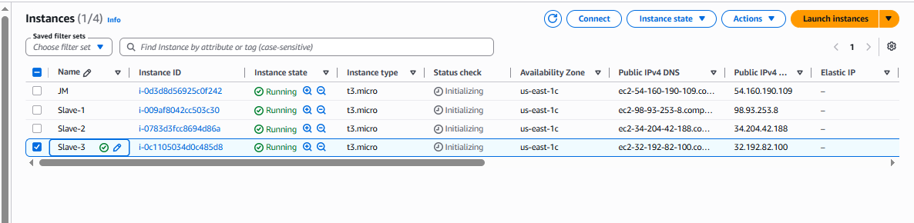

Install java in all machine :
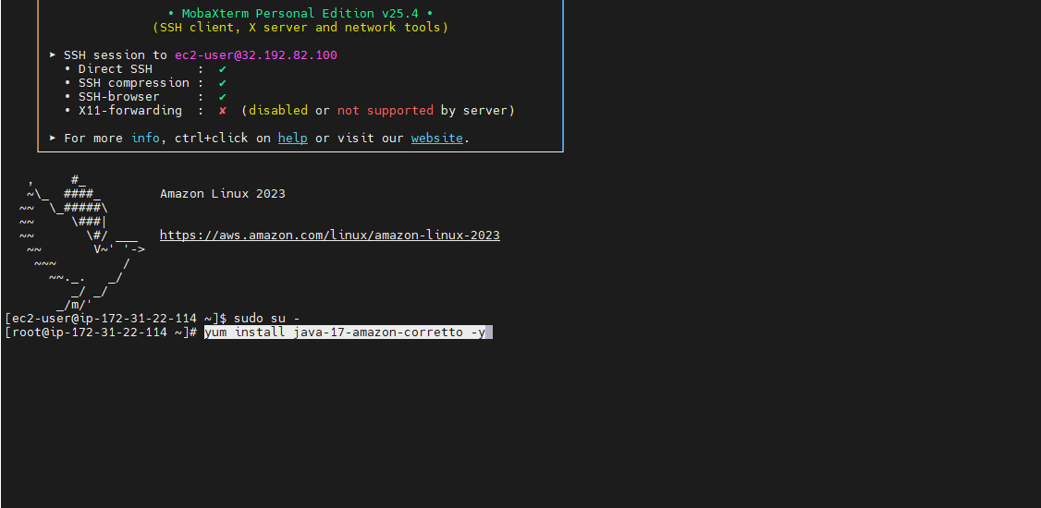

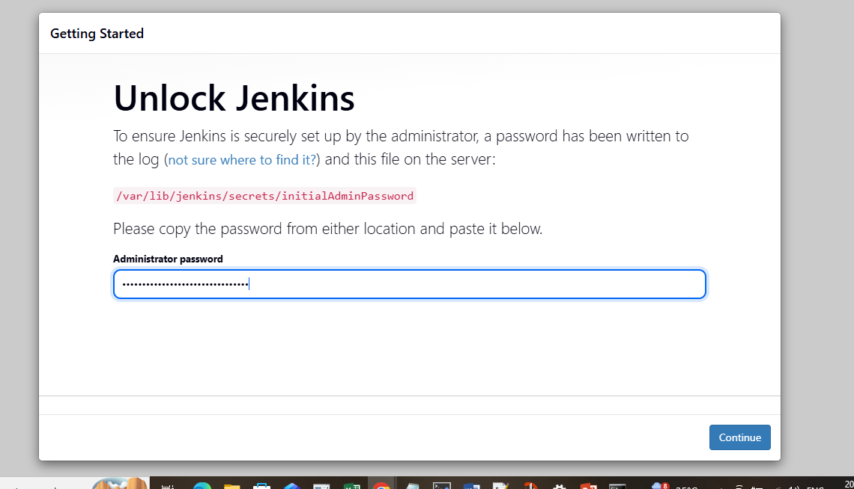

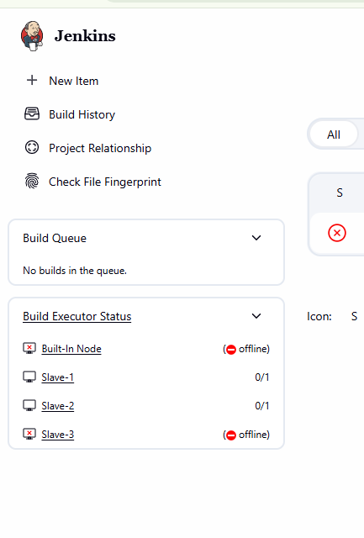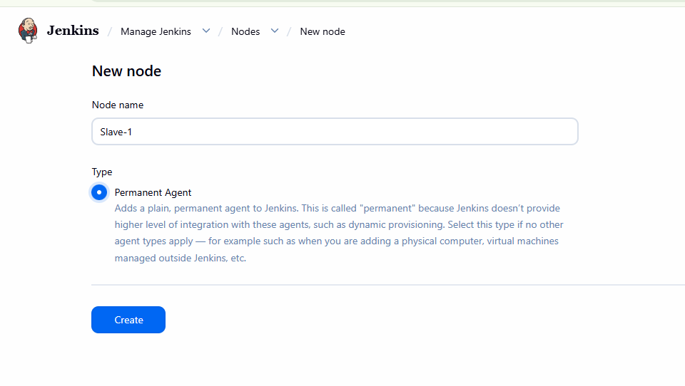

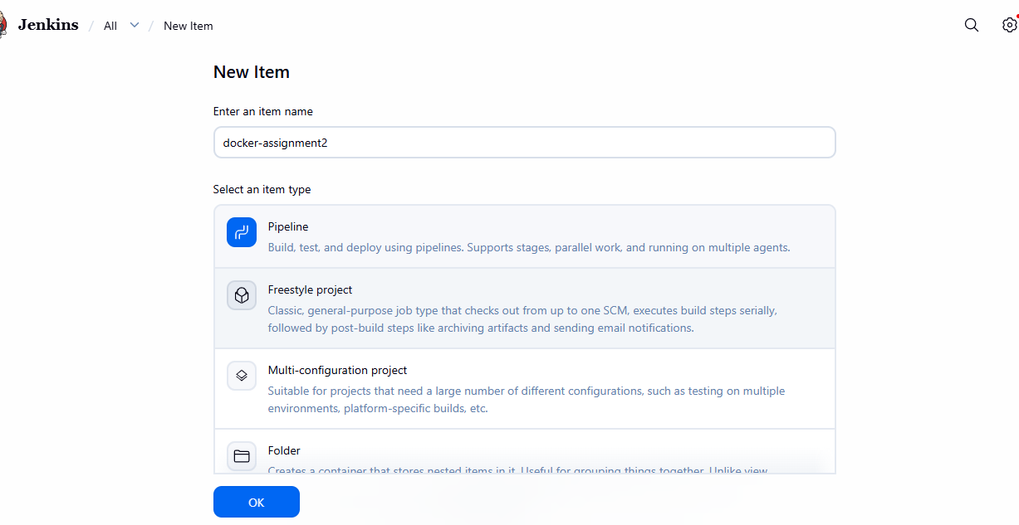
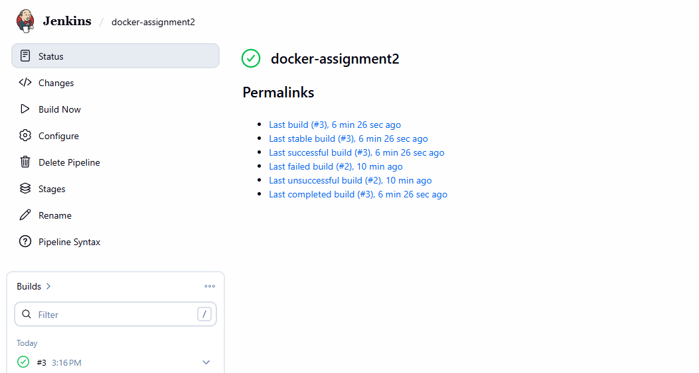

Slave : 1
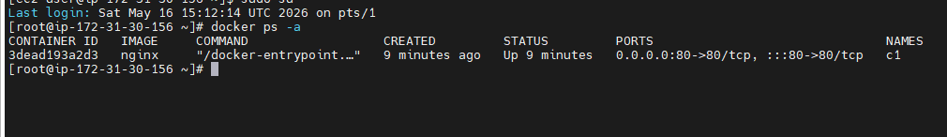
Slave :2
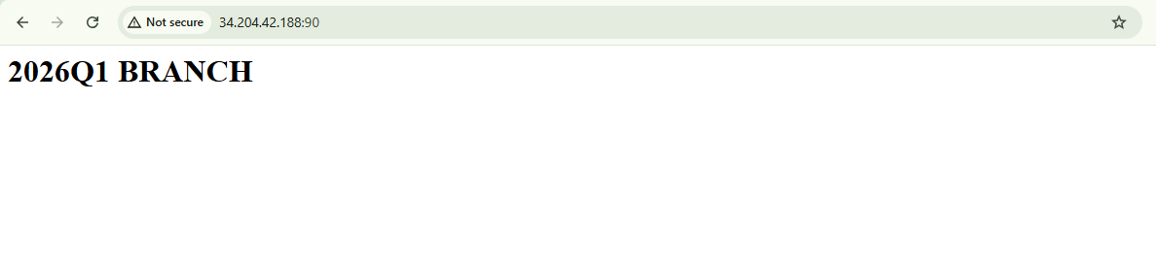
Slave 3:
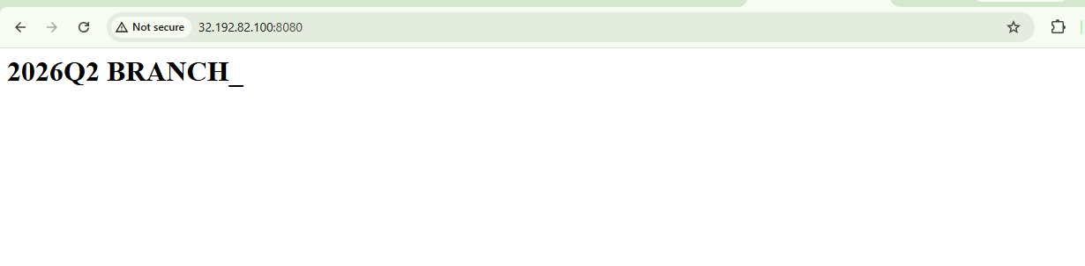

Syntax :
pipeline {

agent none

stages {

stage('Deploy MAIN on Slave1') {

agent { label 'slave1' }

steps {

sh '''
rm -rf repo

git clone -b main https://github.com/Pallavi-250598/Repo-1.git repo

docker rm -f c1 || true

docker run -dit --name c1 -p 80:80 nginx

docker cp repo/index.html c1:/usr/share/nginx/html/index.html
'''
}
}

stage('Deploy Q1 on Slave2') {

agent { label 'slave2' }

steps {

sh '''
rm -rf repo

git clone -b 2026Q1 https://github.com/Pallavi-250598/Repo-1.git repo

docker rm -f c2 || true

docker run -dit --name c2 -p 90:80 nginx

docker cp repo/index.html c2:/usr/share/nginx/html/index.html
'''
}
}

stage('Deploy Q2 on Slave3') {

agent { label 'slave3' }

steps {

sh '''
rm -rf repo

git clone -b 2026Q2 https://github.com/Pallavi-250598/Repo-1.git repo

docker rm -f c3 || true

docker run -dit --name c3 -p 8080:80 nginx

docker cp repo/index.html c3:/usr/share/nginx/html/index.html
'''
}
}
}
}
Command on slaves :
1 yum install java-17-amazon-corretto -y
2 yum install java-21-amazon-corretto.x86_64 -y
3 yum install git -y
4 yum install docker -y
5 systemctl enable docker
6 usermod -aG docker jenkins
7 sudo systemctl start docker
8 sudo systemctl status docker
9 sudo reboot
10 cat /etc/group | grep docker
11 sudo usermod -aG docker ec2-user
12 sudo reboot
13 docker ps -a
14 history

